**Name: ……………………………………………. ADM NO: …………………………………..**

**Student’s signature: ……………………………. Date: ..…………….…………………………**

**FANAKA GIRLS HIGH SCHOOL**

**DECEMBER HOLYDAY ASSIGNMENT**

**AGRICULTURE**

**FORM 2**

**INSTRUCTIONS TO CANDIDATES**

* Write your name and index number in the spaces provided above.
* Answer ALL the questions in the spaces provided in the question paper.

**SECTION A (30mks)**

1a) Define the term agriculture (1mk)

b) Suggest reasons why agriculture is referred to as an art (2mks)

2. State any four branches of agriculture (2mks)

3. State **four** safety precautions that should be observed in working with workshop tools (2mks)

4.Give **four** factors that determine the amount of water required by an animal (2mks)

5. Differentiate between a seedbed and a seedling bed as used in crop production. (1mk)

6.Outline four functions of water in an animal (4mks)

7.Outline **four** types of minerals needed by livestock (2mks)

8.State **two**  importance of raising tomato seedlings in a nursery bed. (1mks)

9.Give **four** ways of controlling weeds in a field of maize. (2mks)

10.Name the intermediate host of the following parasites (1mk)

1. Tape worm:
2. Liver fluke

11.Differentiate between the terms soil texture and soil structure (1mk)

12. A farmer wishes to prepare 500kg of a dairy ration containing 40% crude protein.

He has maize meal containing 30% crude protein and Desmodium cake containing 60% crude proteins.

Using a Pearson Square calculate how much Desmodium cake he will include in the ration. Show your workings. (5mks)

13.Give four characteristics of succulent roughages (2mks)

14.Give four effects of pests on livestock (2mks)

15. Name any four soil structure types in agriculture (2mks)

**SECTION B(20mks)**

16. Below is a diagram of nursery for raising cabbage seedlings.

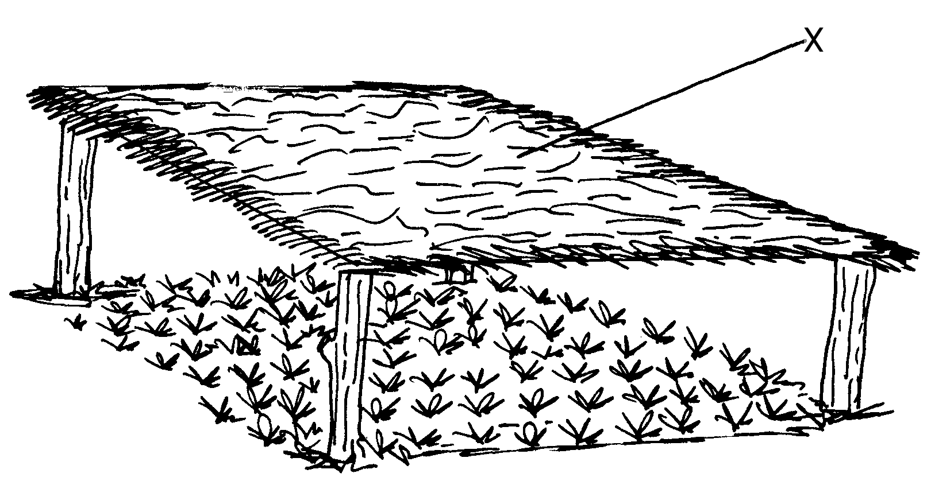

(i) State **four** advantages of the part labeled X (4mks)

(ii) State **four** management practices that should be carried out on the nursery from the time seedlings emerge to the stage of transplanting. (2mks

(iii) At what stage of growth should cabbage seedlings be transplanted. (2mks)

(iv) How would the damage to the seedlings be minimized when uprooting them during Transplanting. (1mk)

17. Below is a diagram of a farm tool.

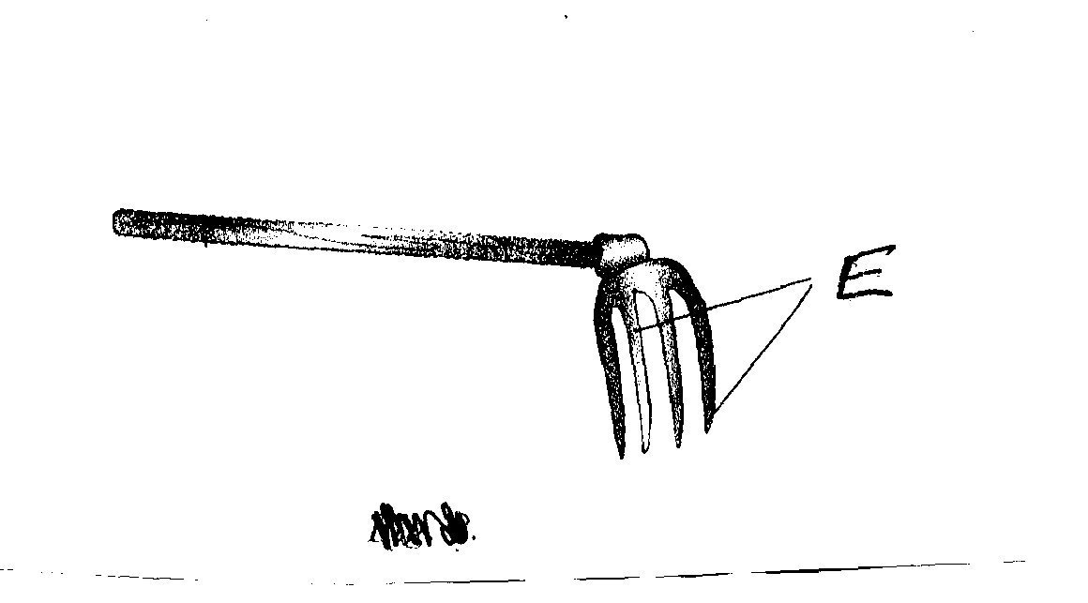

1. i) Identify the tool. (½mk)

ii) Name the part of the tool labeled **E.**  (½mk)

b) State **one** appropriate use of the tool. (1mk)

c) Below is an illustration of an activity carried out to detect an infection of the udder before the actual milking is done.

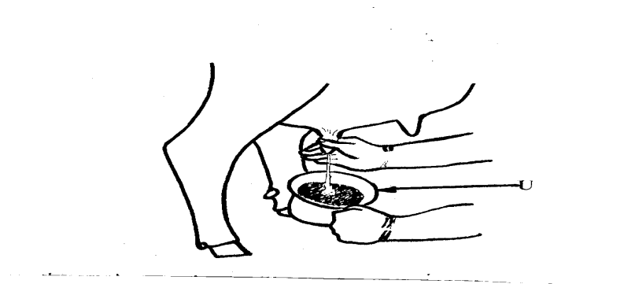

i) Name the equipment in the illustration labeled **U.** (½mk)

ii) State **two** changes that can be observed in milk, using the equipment, if the

udder is injected. (1mk)

18.Study the diagram below and use it to answer the questions that follow

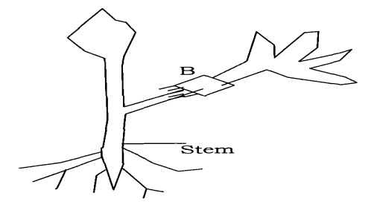

(i) State the method of vegetative propagation shown in B (½ mk)

(ii) State **two** factors that lead to the development of roots in plant B (2mks)

(iii) State **one** limitation of using the above method of propagation (1mk)

19.The diagram below illustrates livestock deficiency diseases. Study the diagram and answer the questions that follow.

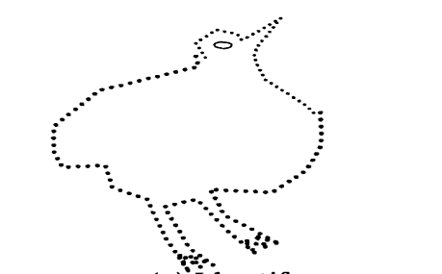

(a) Identify

(i) The diseases (½ mk)

(ii) The deficient nutrient (½ mk)

(b) (i) Apart from head refraction, state two other symptoms of the deficiency

Disease (2mks)

(c) State one role of the nutrient named in a (i) above (1mk)

**SECTION C(40mks)**

**Answer any TWO questions from this section in the spaces provided .**

20. a) Describe life cycle of a two host tick. (10mks)

b) Describe any 5 non chemical methods of controlling ticks 10mks

21. Describe the production of cabbages under the following subheadings

a) Ecological requirements 4mks

b) Transplanting 3mks

c) Planting 5mks

d) Field management practices 6mks

e) Harvesting and marketing 2mks

22. a) Briefly explain the signs of ill health in animals 10mks

b) Discuss the general methods of disease control 10mks